Quarch Technology Ltd
AN-020
Application Note

Module control with config files

For use with:
Torridon hot-swap / Breaker modules

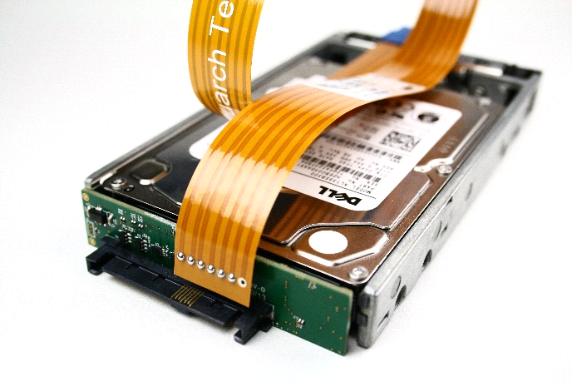

Change History
1.0 | March 2020 | Initial Release
1.1 | March 2023 | Removed duplicate content
1.2 | March 2023 | Updated after app note review

Introduction
Quarch modules can be easily automated via their text commands. Each module has differences though: While the main commands are the same, each module has a different list of signals that can be controlled, and some have additional advanced features.
These special cases are described in a set of ‘configuration files’ which are supplied with the quarchpy package. Using a few simple functions, you can locate the config file for your module and use this to list the full capabilities of the device.
This mechanism is used in TestMonkey to provide control over every Quarch module, and is now being released for customer use.
- No additional library installs are required (other than quarchpy). Config files will automatically update with quarchpy, as new modules are released

Requirements
- Python 3.x
- Quarchpy python package
- Quarch breaker/hot-swap module.
- Power and Switch modules are NOT yet supported

Application Note Example Files
The AN-020.zip should be extracted to your preferred location.
DeviceCapabilities.py
Simple example, showing how to link the module with the correct configuration file then print out the major parts of the capabilities to the terminal

Script example run
- Run the list devices script, to check which modules are available to you
>python DeviceCapabilities.py
First we are asked to select a module to connect to. Only Torridon breaker/hot-swap modules are currently supported
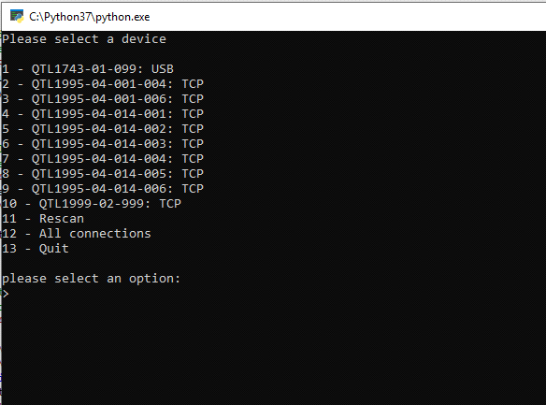

After selecting the module, the script will parse the appropriate file then display a dump of the product’s capabilities
